**2021/2022 Semester 2: 1004 Tutorial 7**

**Q1 Lay/Ch5.1/pg271/Ex6+7**

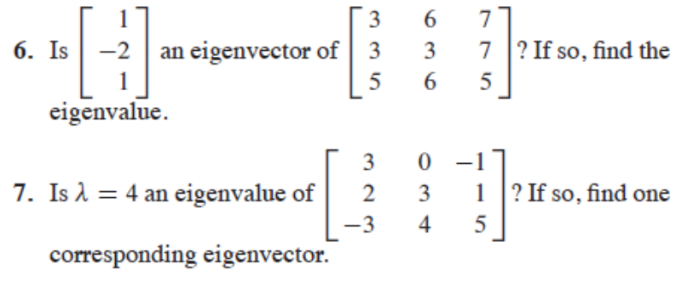

**Q2: Find the eigenvalues & eigenvectors of**



**Q3) Lay/Ch5/pg272/**

**Find an eigen -basis of the -2 eigenspace of A.**

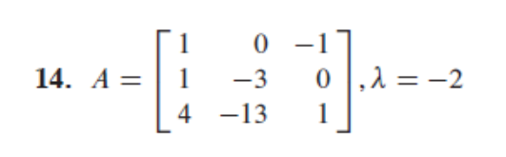

**Q4: If {u,v} are linearly independent eigenvectors, then they must correspond to distinct eigenvalues.**

**Q5) Lay/ch5.1/pg 274/Q5**

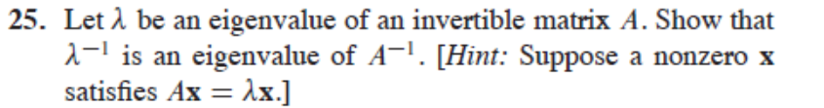

**Q6) Lay/Ch5.3/pg288**

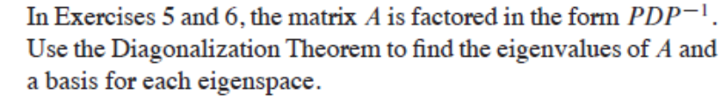

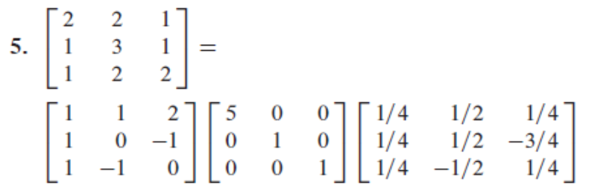

**Q7) Lay/Ch5.3/pg 289/Q21+23**

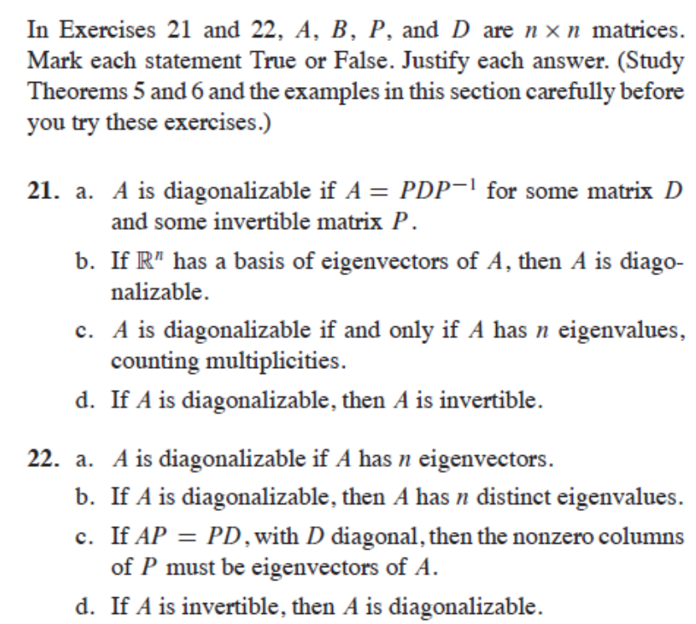

Q8) Lay./Ch5.3/pg289/Q31+32

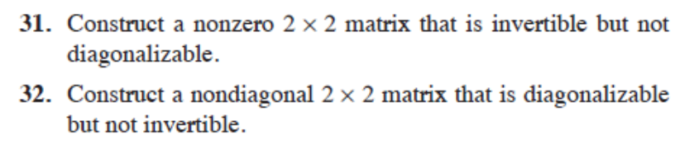

### 

Q9) Lay/ch5.6/pg 311/Practise

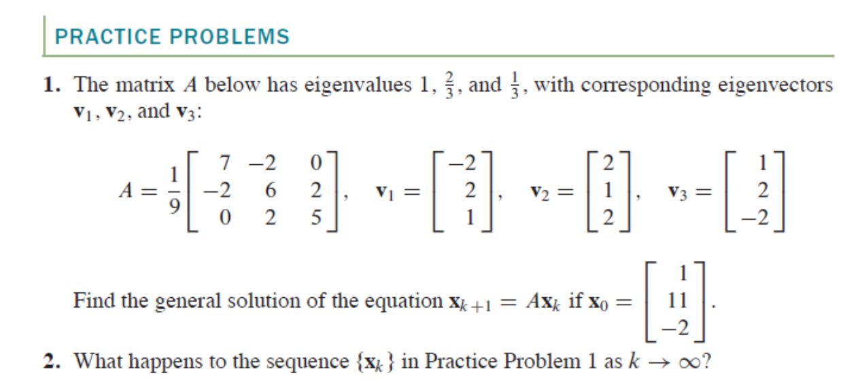

Q10:

